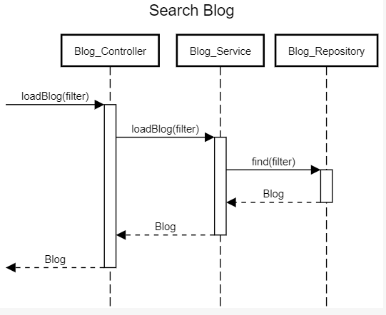

title Search Blog

autoactivation

[->Blog_Controller:loadBlog(filter)

Blog_Controller->Blog_Service:loadBlog(filter)

Blog_Service->Blog_Repository:find(filter)

Blog_Service<--Blog_Repository:Blog

Blog_Controller<--Blog_Service:Blog

[<--Blog_Controller:Blog

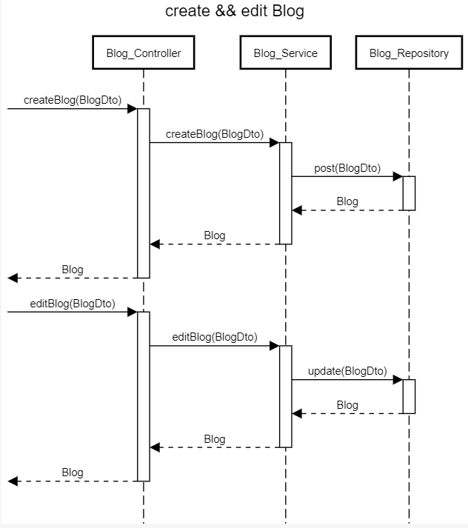

title create && edit Blog

autoactivation

[->Blog_Controller:createBlog(BlogDto)

Blog_Controller->Blog_Service: createBlog(BlogDto)

Blog_Service->Blog_Repository:post(BlogDto)

Blog_Repository-->Blog_Service:Blog

Blog_Service-->Blog_Controller:Blog

Blog_Controller-->[:Blog

[->Blog_Controller:editBlog(BlogDto)

Blog_Controller->Blog_Service: editBlog(BlogDto)

Blog_Service->Blog_Repository:update(BlogDto)

Blog_Repository-->Blog_Service:Blog

Blog_Service-->Blog_Controller:Blog

Blog_Controller-->[:Blog

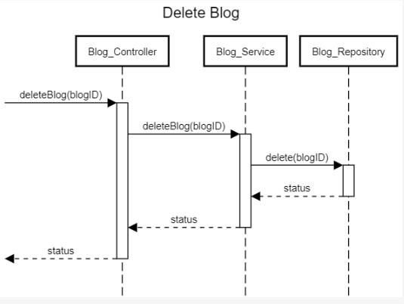

title Delete Blog

autoactivation

[->Blog_Controller: deleteBlog(blogID)

Blog_Controller->Blog_Service: deleteBlog(blogID)

Blog_Service->Blog_Repository: delete(blogID)

Blog_Repository-->Blog_Service: status

Blog_Service-->Blog_Controller: status

Blog_Controller-->[: status

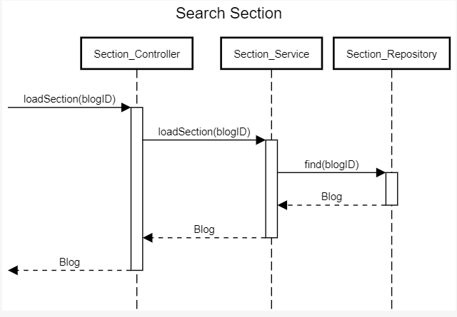

title Search Section

autoactivation

[->Section_Controller:loadSection(blogID)

Section_Controller->Section_Service:loadSection(blogID)

Section_Service->Section_Repository:find(blogID)

Section_Service<--Section_Repository:Blog

Section_Controller<--Section_Service:Blog

[<--Section_Controller:Blog

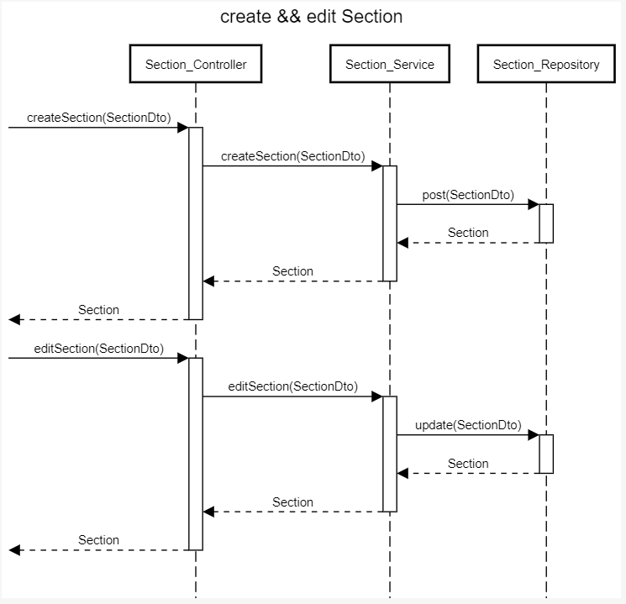

title create && edit Section

autoactivation

[->Section_Controller:createSection(SectionDto)

Section_Controller ->Section_Service:createSection(SectionDto)

Section_Service ->Section_Repository:post(SectionDto)

Section_Repository -->Section_Service:Section

Section_Service -->Section_Controller:Section

Section_Controller -->[:Section

[->Section_Controller:editSection(SectionDto)

Section_Controller ->Section_Service:editSection(SectionDto)

Section_Service ->Section_Repository:update(SectionDto)

Section_Repository -->Section_Service:Section

Section_Service -->Section_Controller:Section

Section_Controller -->[:Section

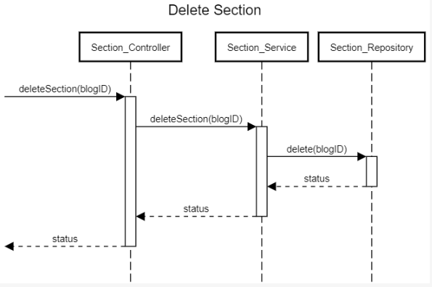

title Delete Section

autoactivation

[->Section_Controller: deleteSection(blogID)

Section_Controller->Section_Service: deleteSection(blogID)

Section_Service->Section_Repository: delete(blogID)

Section_Repository-->Section_Service: status

Section_Service-->Section_Controller: status

Section_Controller-->[: status

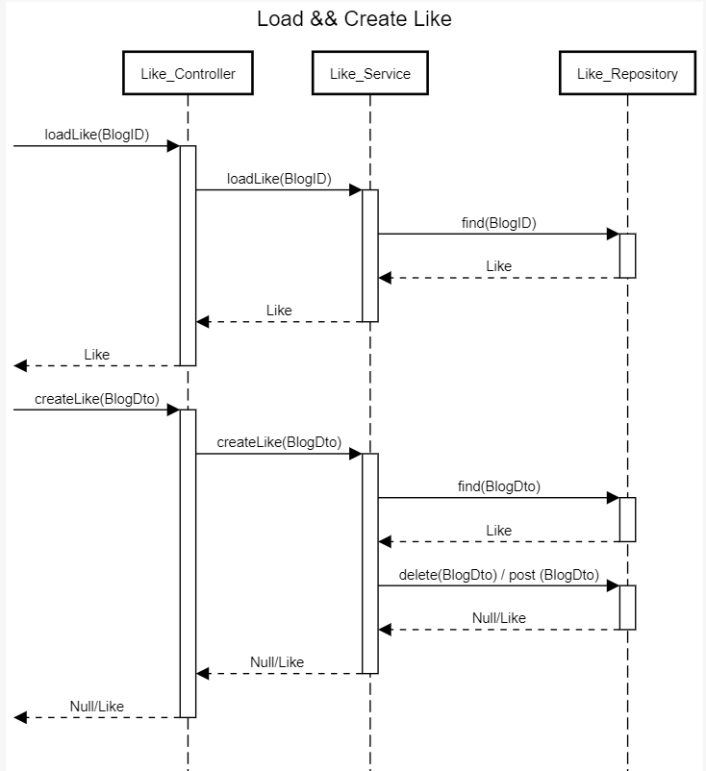

title Load && Create Like

autoactivation

[->Like_Controller:loadLike(BlogID)

Like_Controller->Like_Service:loadLike(BlogID)

Like_Service->Like_Repository:find(BlogID)

Like_Repository-->Like_Service:Like

Like_Service-->Like_Controller:Like

[<--Like_Controller:Like

[->Like_Controller:createLike(BlogDto)

Like_Controller->Like_Service:createLike(BlogDto)

Like_Service->Like_Repository:find(BlogDto)

Like_Repository-->Like_Service:Like

Like_Service->Like_Repository:delete(BlogDto) / post (BlogDto)

Like_Repository-->Like_Service:Null/Like

Like_Service-->Like_Controller:Null/Like

[<--Like_Controller:Null/Like

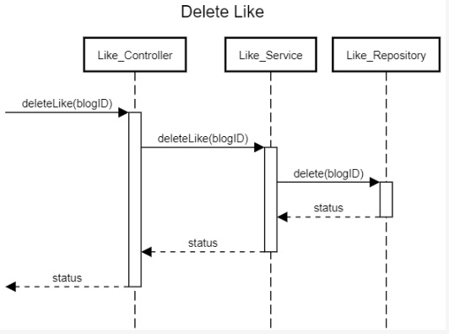

title Delete Like

autoactivation

[->Like_Controller: deleteLike(blogID)

Like_Controller->Like_Service:deleteLike(blogID)

Like_Service->Like_Repository:delete(blogID)

Like_Repository-->Like_Service:status

Like_Service-->Like_Controller:status

Like_Controller-->[: status

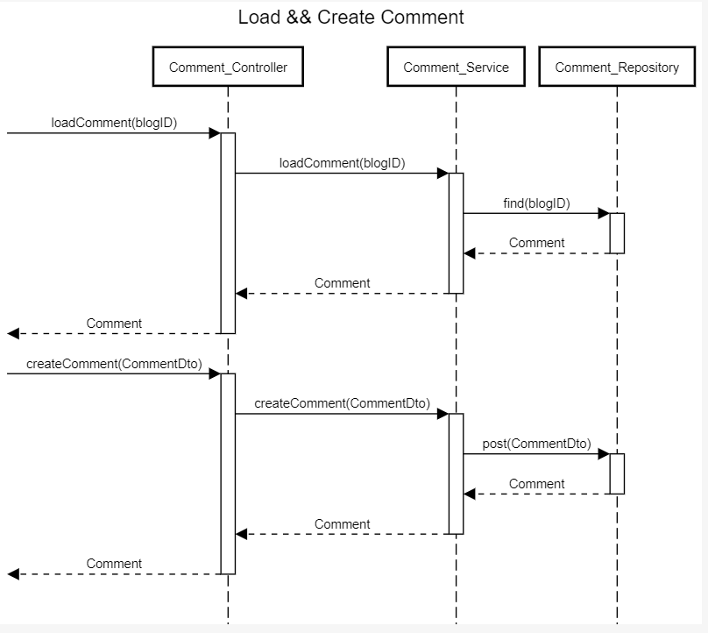

title Load && Create Comment

[->Comment_Controller: loadComment(blogID)

Comment_Controller->Comment_Service: loadComment(blogID)

Comment_Service->Comment_Repository: find(blogID)

Comment_Repository-->Comment_Service: Comment

Comment_Service-->Comment_Controller: Comment

[<--Comment_Controller:Comment

[->Comment_Controller:createComment(CommentDto)

Comment_Controller->Comment_Service:createComment(CommentDto)

Comment_Service->Comment_Repository:post(CommentDto)

Comment_Repository-->Comment_Service:Comment

Comment_Service-->Comment_Controller:Comment

[<--Comment_Controller:Comment

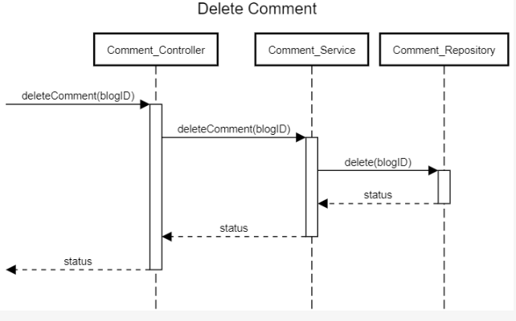

title Delete Comment

autoactivation

[->Comment_Controller: deleteComment(blogID)

Comment_Controller->Comment_Service:deleteComment(blogID)

Comment_Service->Comment_Repository:delete(blogID)

Comment_Repository-->Comment_Service:status

Comment_Service-->Comment_Controller:status

Comment_Controller-->[: status

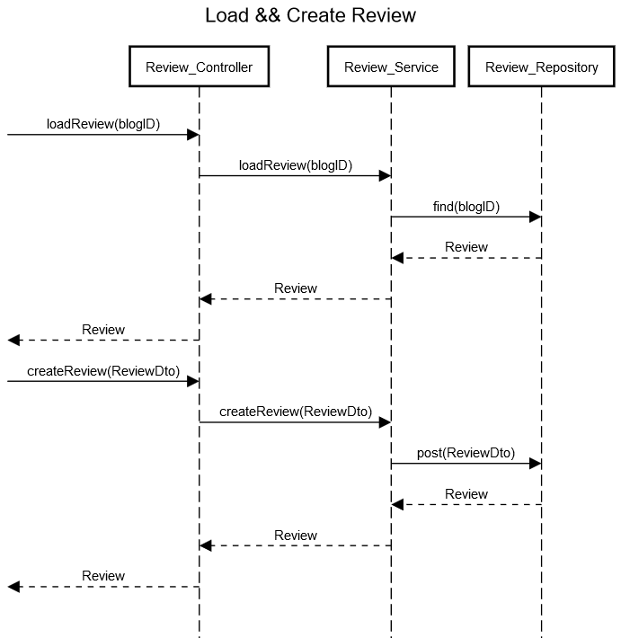

title Load && Create Review

[->Review_Controller: loadReview(blogID)

Review_Controller->Review_Service: loadReview(blogID)

Review_Service->Review_Repository: find(blogID)

Review_Repository-->Review_Service: Review

Review_Service-->Review_Controller: Review

[<--Review_Controller:Review

[->Review_Controller:createReview(ReviewDto)

Review_Controller->Review_Service:createReview(ReviewDto)

Review_Service->Review_Repository:post(ReviewDto)

Review_Repository-->Review_Service:Review

Review_Service-->Review_Controller:Review

[<--Review_Controller:Review

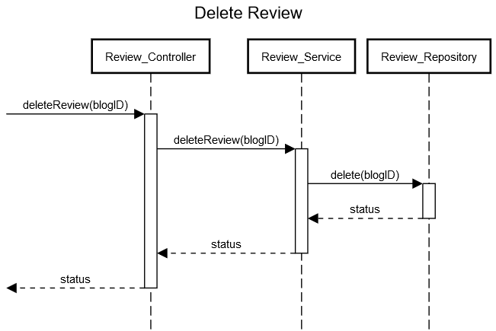

title Delete Review

autoactivation

[->Review_Controller: deleteReview(blogID)

Review_Controller->Review_Service:deleteReview(blogID)

Review_Service->Review_Repository:delete(blogID)

Review_Repository-->Review_Service:status

Review_Service-->Review_Controller:status

Review_Controller-->[: status

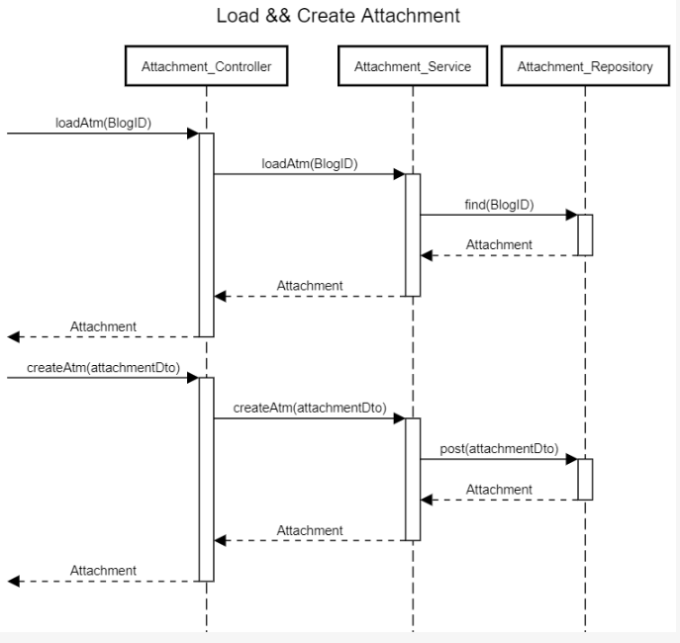

title Load && Create Attachment

participant "Attachment_Controller" as fc

participant "Attachment_Service" as fs

participant "Attachment_Repository" as fr

autoactivation

[->fc: loadAtm(BlogID)

fc->fs:loadAtm(BlogID)

fs->fr:find(BlogID)

fr-->fs:Attachment

fs-->fc:Attachment

fc-->[:Attachment

[->fc: createAtm(attachmentDto)

fc->fs:createAtm(attachmentDto)

fs->fr:post(attachmentDto)

fr-->fs:Attachment

fs-->fc:Attachment

fc-->[:Attachment

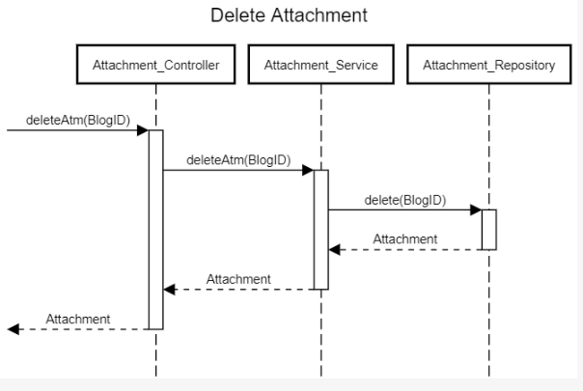

title Delete Attachment

participant "Attachment_Controller" as fc

participant "Attachment_Service" as fs

participant "Attachment_Repository" as fr

autoactivation

[->fc: deleteAtm(BlogID)

fc->fs:deleteAtm(BlogID)

fs->fr:delete(BlogID)

fr-->fs:Attachment

fs-->fc:Attachment

fc-->[:Attachment

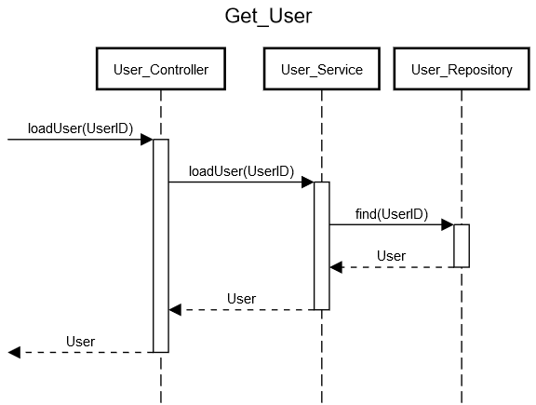

title Get_User

autoactivation

[->User_Controller: loadUser(UserID)

User_Controller->User_Service: loadUser(UserID)

User_Service->User_Repository:find(UserID)

User_Repository-->User_Service:User

User_Service-->User_Controller:User

User_Controller-->[:User

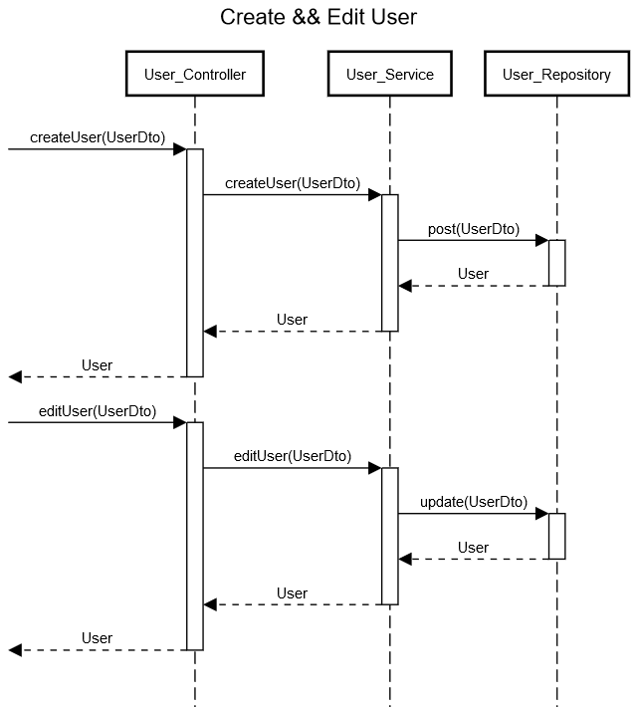

title Create && Edit User

autoactivation

[->User_Controller: createUser(UserDto)

User_Controller->User_Service: createUser(UserDto)

User_Service->User_Repository:post(UserDto)

User_Repository-->User_Service:User

User_Service-->User_Controller:User

User_Controller-->[:User

[->User_Controller: editUser(UserDto)

User_Controller->User_Service: editUser(UserDto)

User_Service->User_Repository:update(UserDto)

User_Repository-->User_Service:User

User_Service-->User_Controller:User

User_Controller-->[:User

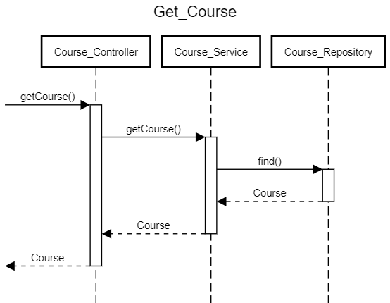

title Get_Course

autoactivation

[->Course_Controller:getCourse()

Course_Controller->Course_Service: getCourse()

Course_Service->Course_Repository:find()

Course_Repository-->Course_Service:Course

Course_Service-->Course_Controller:Course

Course_Controller-->[:Course

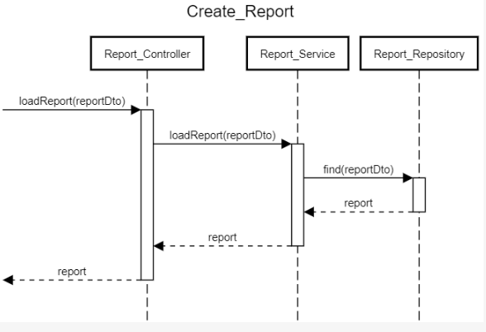

title Create_Report

autoactivation

[->Report_Controller: loadReport(reportDto)

Report_Controller->Report_Service: loadReport(reportDto)

Report_Service->Report_Repository:find(reportDto)

Report_Repository-->Report_Service:report

Report_Service-->Report_Controller:report

Report_Controller-->[:report